web programming  
LAB 10

23BCE 1016 Tarun Chebolu

Question-1

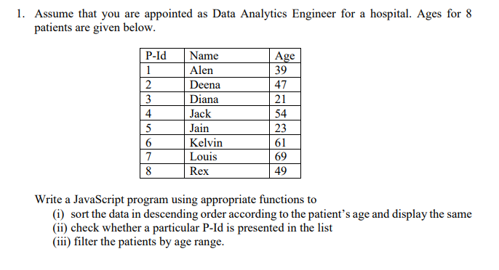

Code

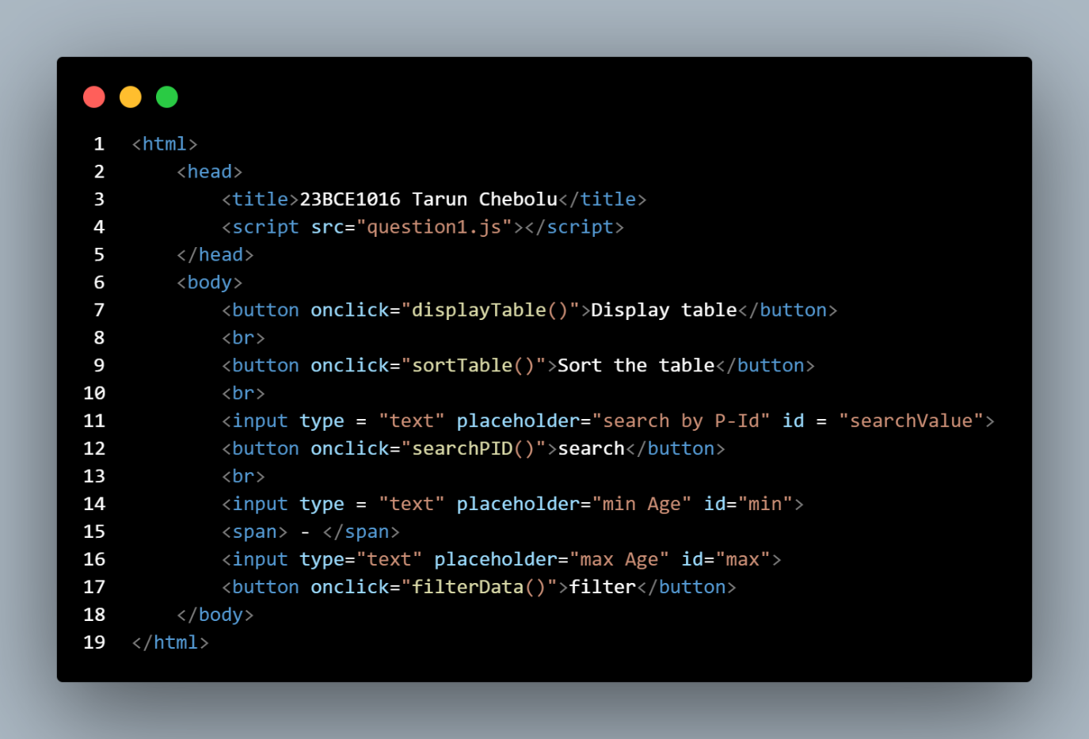

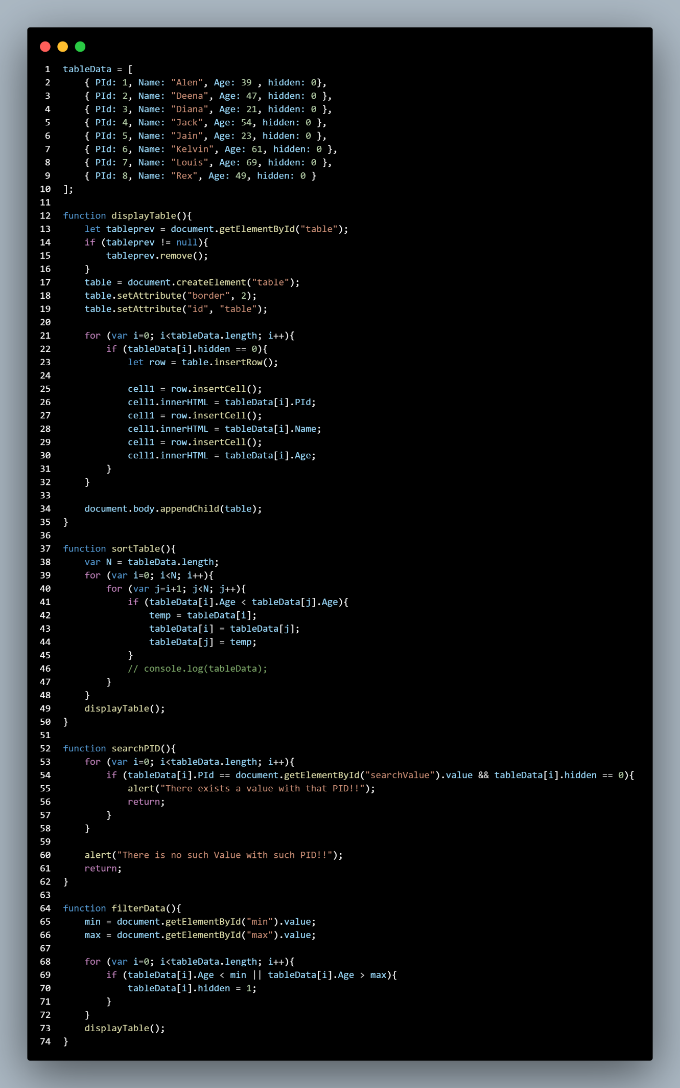

Output

Code

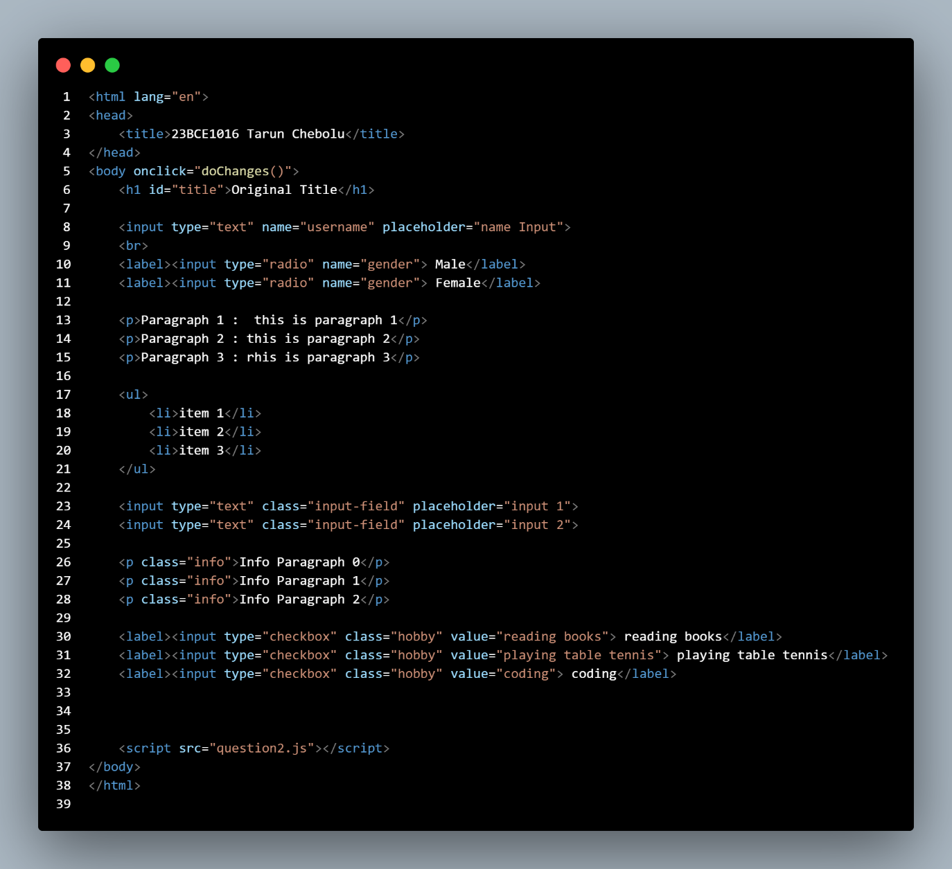

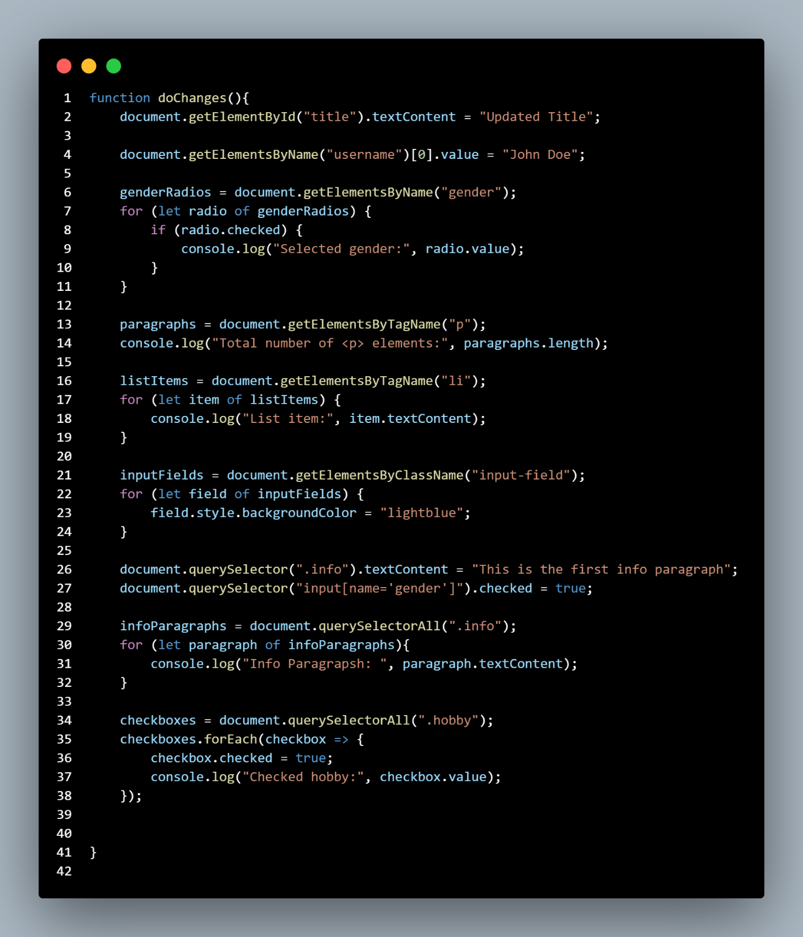

Output

Question-3

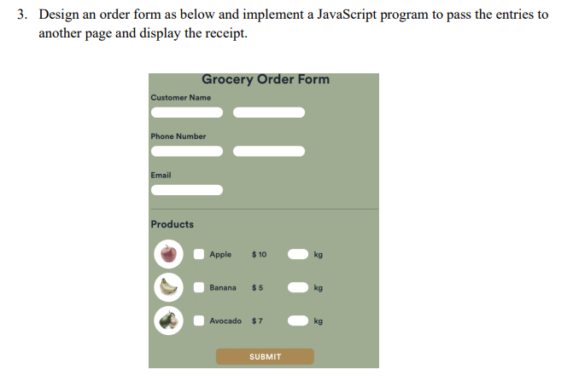

Code

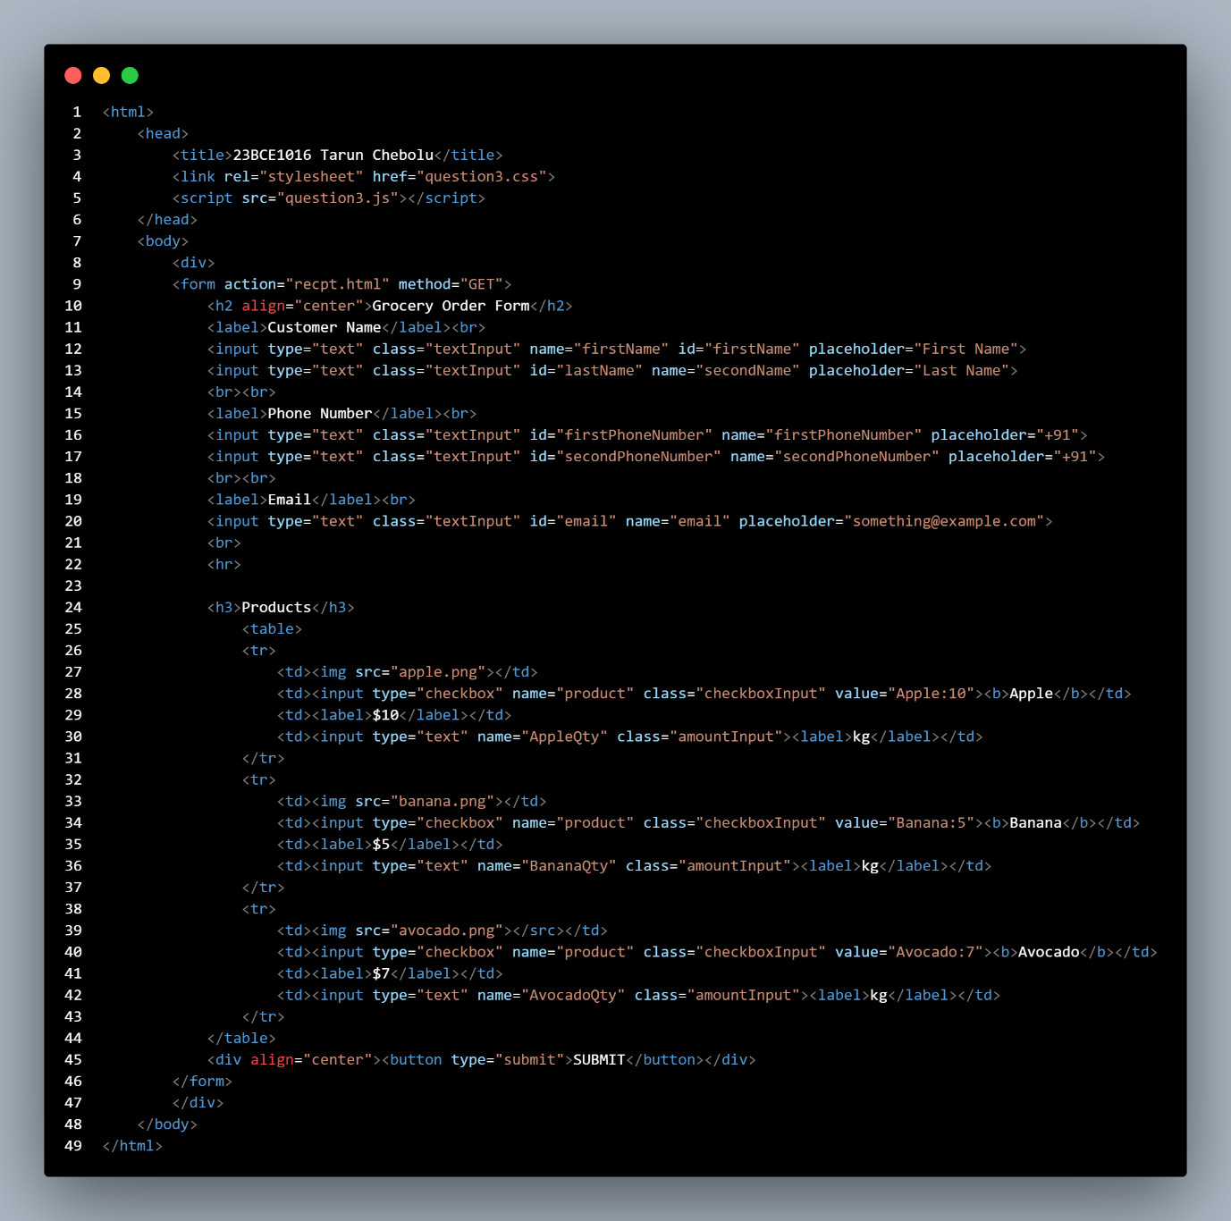

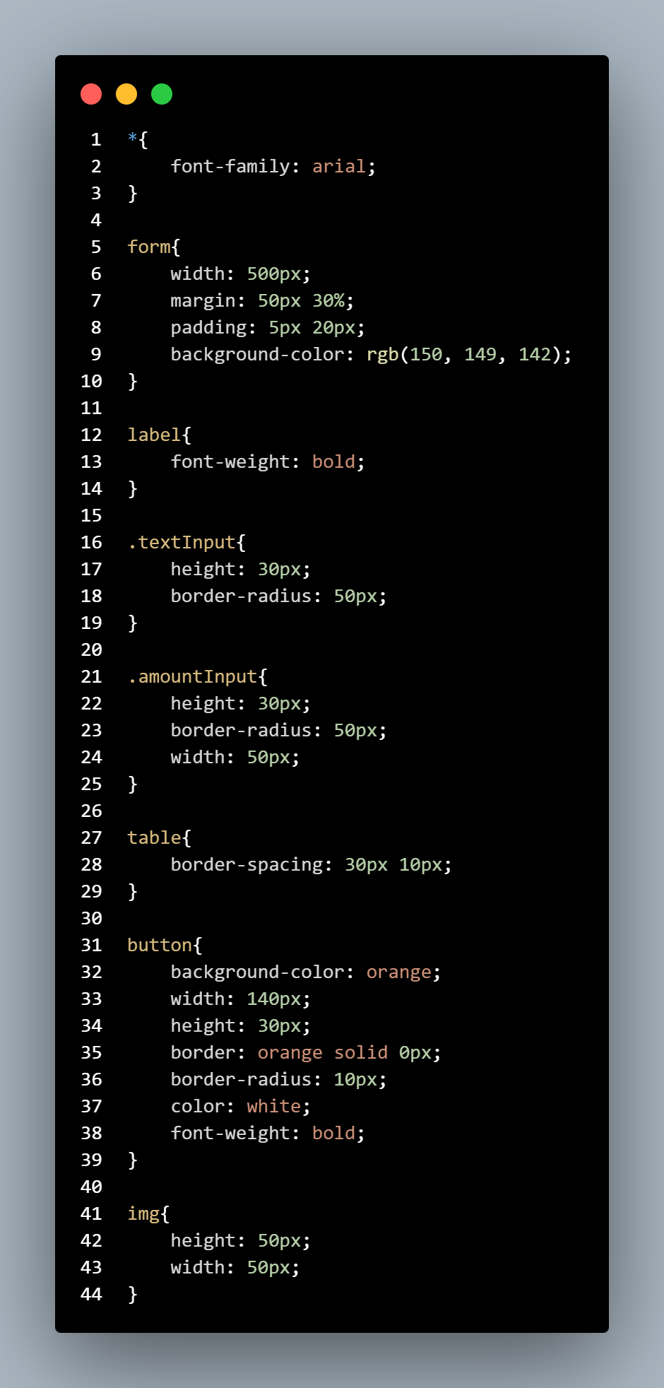

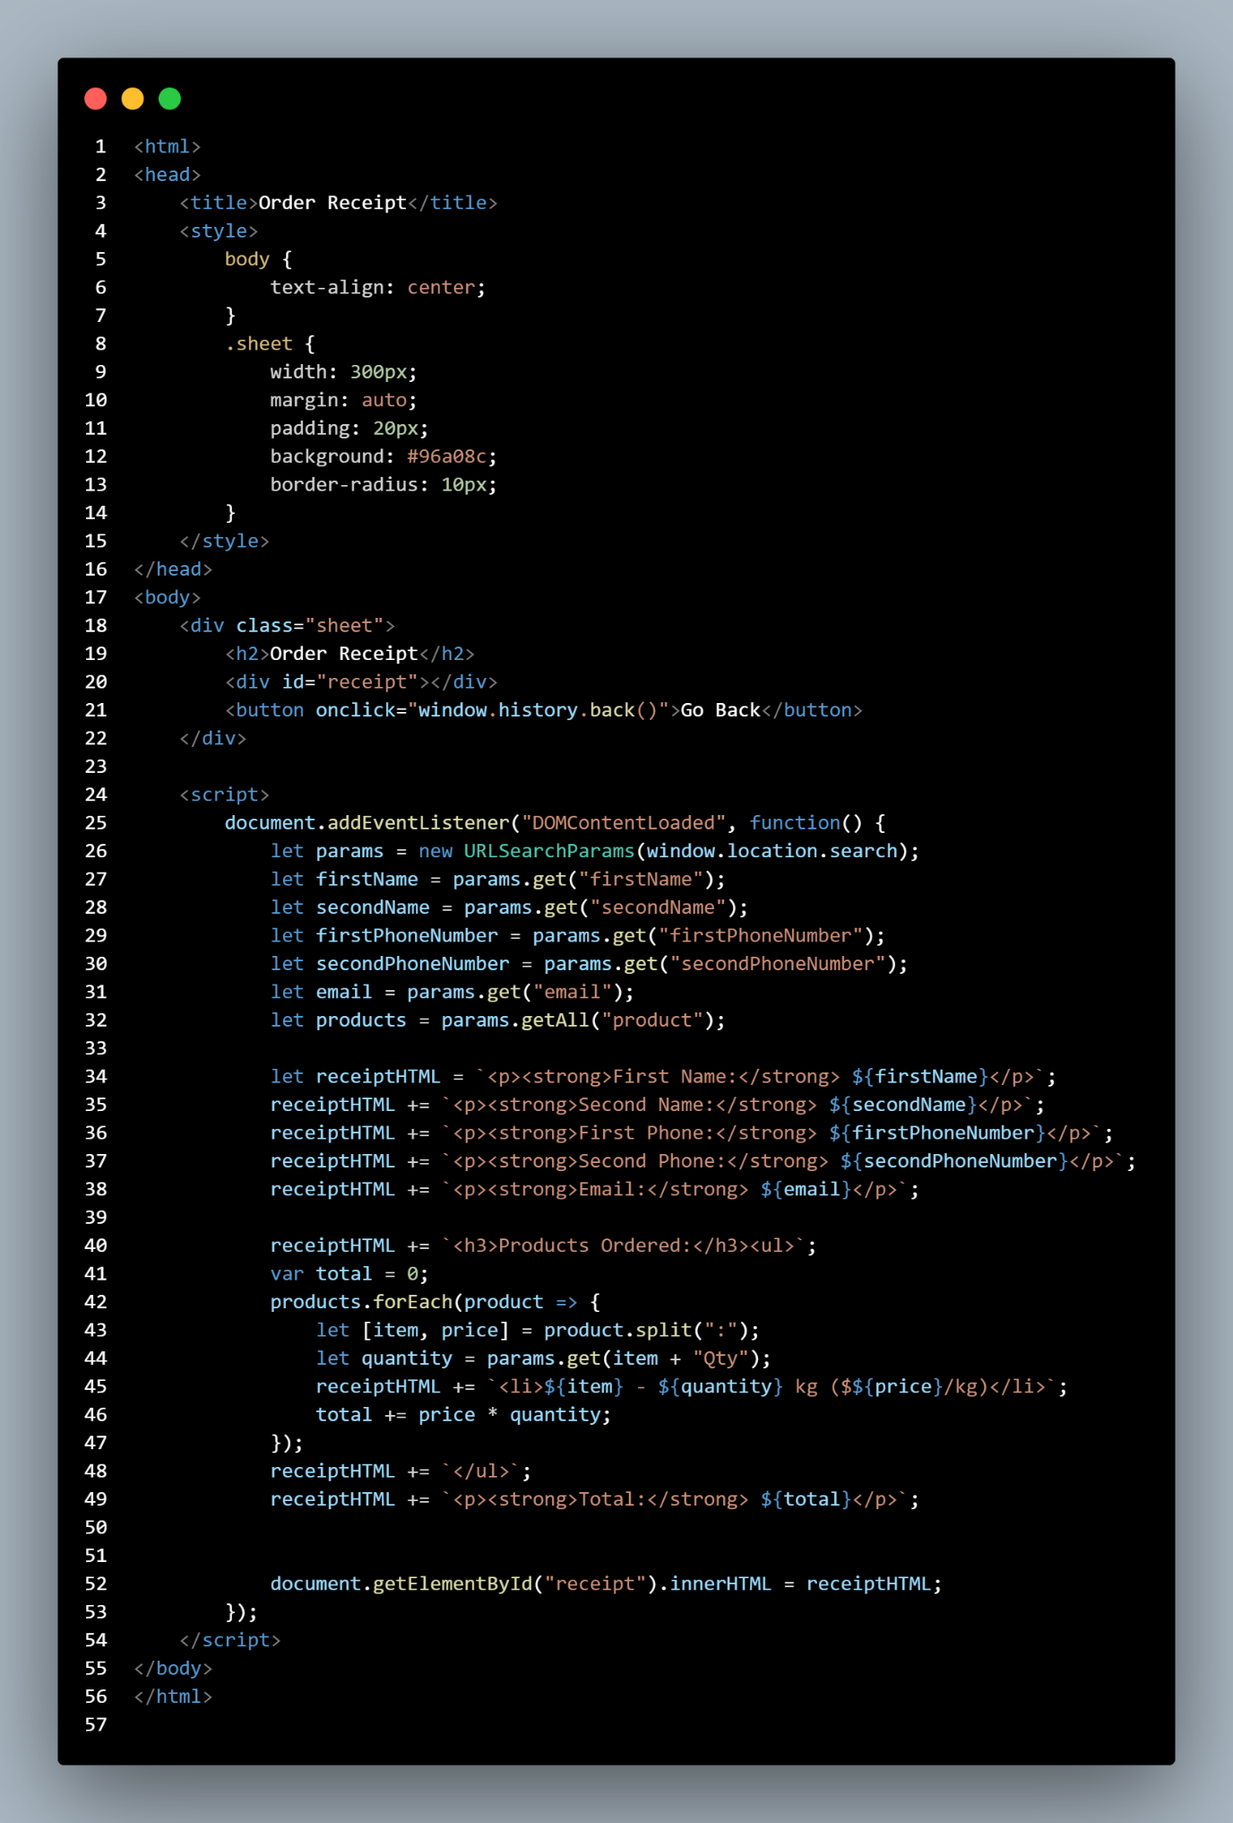



Output

